Training Portal Log In Page: http://trainingportal-mileage.rhcloud.com/login.zul
Once you have registered in the portal, you will receive an email that contains your username and password. Please key in the information to log in. You will need to change the password during your first log in.
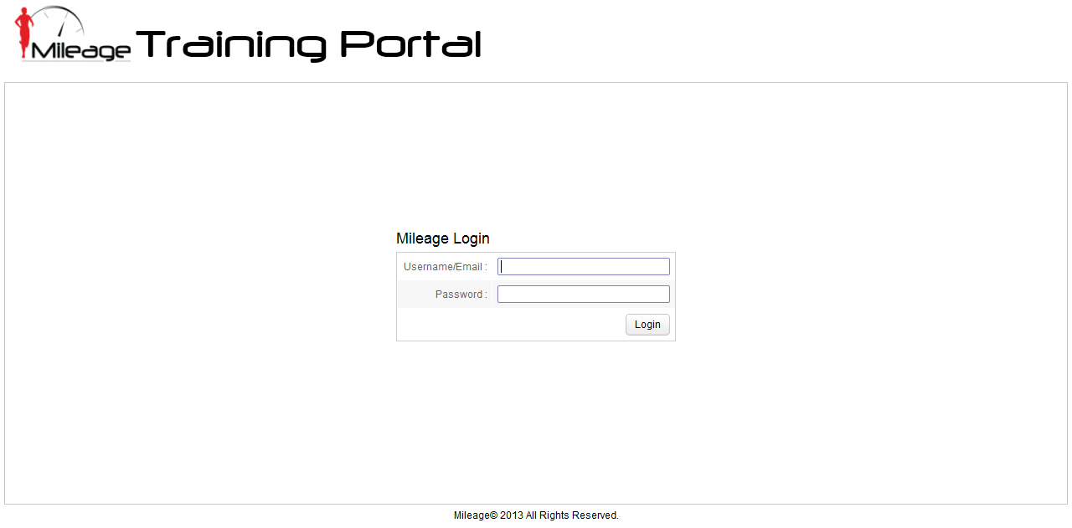

Training Portal – Member’s Homepage
1. Username
2. To change password.
3. To log out
All latest training plans /race before member’s update will be stated here. You can click and update the training/race in “Training Update page” directly. Please check page 5 for details.
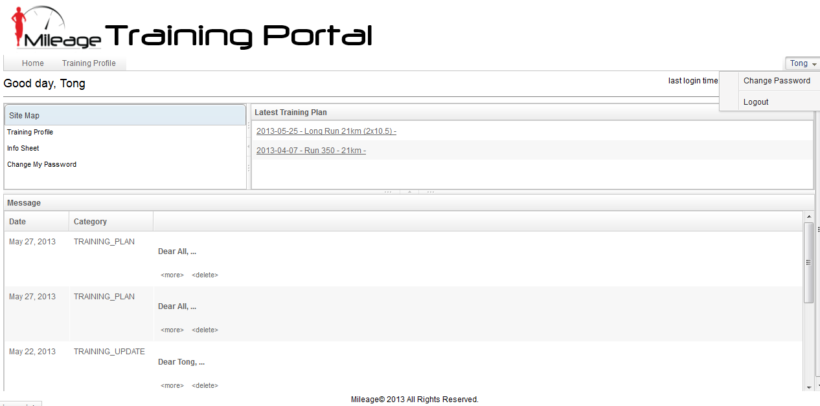
All training plan, update emails can be seen here as well. You should receive the same messages in your mailbox too. You can delete the messages here directly.
Link to member’s training profile. Please check page 3 for the details.
Info Sheet, please check in to fill up all the details. Check page 4 for details.

Training Profile
This page will keep track of your races, personal best of different distance but you have to fill up the official formal distance like marathon 42.195km. Then the system will compare your latest race result with old record and update the personal best accordingly.
Calendar below contains your various training plan (in Red), you can click to check the training details. You may also click on the empty calendar to write down your note, for example 6 May – 9 May “Overseas” in green.
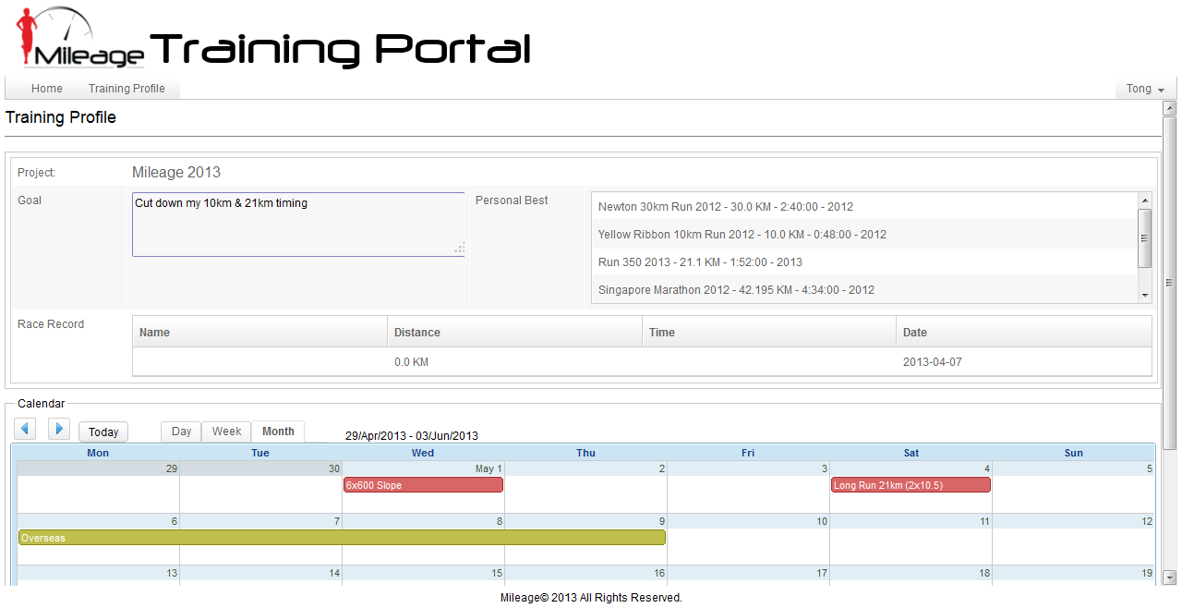

Member’s Information Sheet – Screen 1
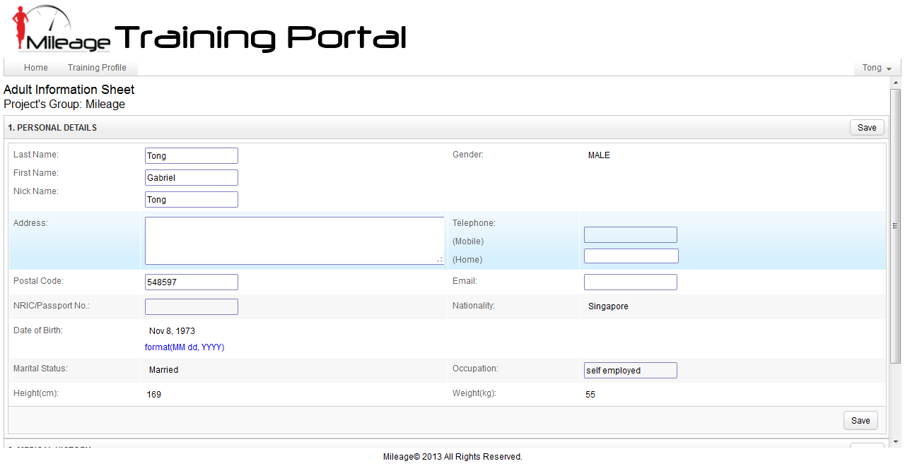
Member’s Information Sheet – Screen 2
There are total 4 sections to fill up, please remember to click “Save” button on top right of the section bar to save the information.
After you fill up the specific section, you can click on the top bar of the section to close the section window like screen 2.
The default is only 1 Emergency contact and 1 Personal Best to be filled up but you can click the “Add” and “Add Personal Best” button to key in more after you fill up the first one.

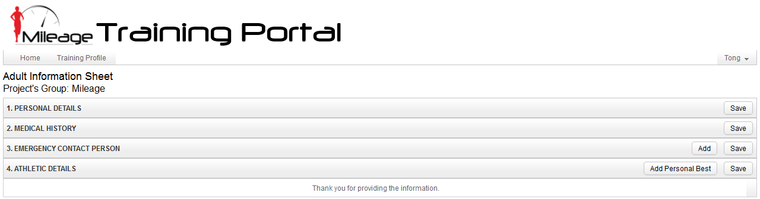
Training Update Page:
You will be able to key in your “Training” or “Race” Timing and your comment here. Once you have updated the necessary information, click “Save & Send”. The system will generate an email to both athlete and coach.
Coach can log in and fill up his comment as feedback. The system will generate another email after his update.
